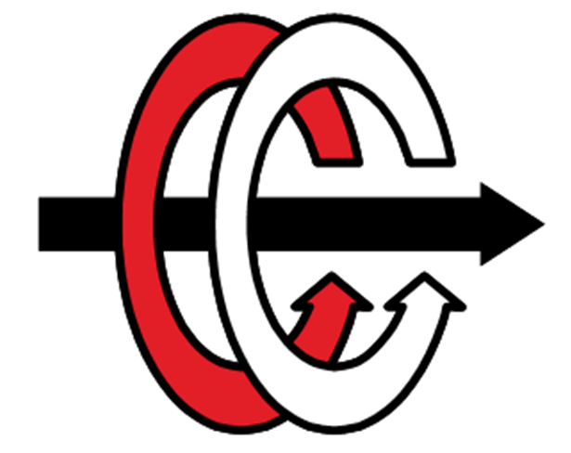

Middle East Technical University

Electrical & Electronics Engineering Department

EE463 – Static Power Conversion I

Hardware Project

Complete Simulation Report

Yasin Enes Çalışkan 2304319

Başak Koca 2232304

Mehmet Hakan Yel

# **Introduction**

For the motor drive system in the power electronics field, converters and rectifiers are essential. This project involves designing an AC/DC converter. The potential topologies discussed in this simulation report. The topology selection is made with respect to advantages and disadvantages of the design. The computation and simulations are provided for the chosen topology. There are both ideal and non-ideal instances in the simulations. The necessary components are selected utilizing the findings of studies following simulation and calculation analysis. Thermal analysis of the system is made.

# **Problem Definition**

Designing a controlled rectifier to drive a DC motor is a requirement for this project. The variable AC source is employed as the input. A kettle is wired to the DC motor and used to boil water.

Input and output constraints:

* Input: Three phase or single-phase AC
* Output: DC Output, Vdcmax <180 V

Motor specifications:

* Armature Winding: 0.8 Ω, 12.5 mH
* Shunt Winding: 210 Ω, 23 H
* Interpoles Winding: 0.27 Ω, 12 mH

# **Possible Topologies for Solution**

## **Single Phase Thyristor Rectifier**

The Single-Phase Thyristor Rectifier design provides regulated operation. There are four thyristors in the topology. By altering the thyristors' firing angle, the rectifier's average output voltage can be changed. Therefore, with this architecture, we can convert AC to variable DC.

Applying a pulse signal to the thyristors' gate terminals regulates how they fire. The zero crossings of the input ac waveform should be recognized to synchronize the thyristors' firing timings. There must be a 180-degree phase difference between the firing angles. There is significant output voltage ripple. A capacitor with a high capacitance can be added to the system to decrease the high voltage ripple at the output.

There are two modes of single-phase thyristor rectifier. Average output voltage and current are positive when in rectification mode. Power flows through the rectifier in this mode from the input side to the output side. On the other hand, average output voltage turns negative while the output current remains positive in the inverter mode of operation. The power flows from output side to input side. Thus, the rectifier feeds power back into the grid. Average output voltage is seen in equation 1.

Vav=(2√2)/π Vph cosα (1)

**Advantages**

* Due to the fewer thyristors needed, it is affordable and small.
* By coupling two Single Phase Thyristor Rectifier circuits, it may be operated in four quadrants. If there is an active source on the rectifier's output side when it is in inverter mode, it can send power back to the grid. A positive current can flow while the output voltage remains positive.

**Disadvantages**

* The output has a high voltage ripple.
* It causes large harmonics in current. It can be reduced by adding inductor to the input, however that causes to increase in commutation time.
* It has low power factor.
* It is challenging to organize firing angles synchronously and extra circuits and sources are required to drive thyristors.
* A lower average output voltage than a three-phase thyristor rectifier.



*Figure 1. Single Phase Thyristor Rectifier with RL Load*

## **Three Phase Thyristor Rectifier**



*Figure x. Three phase thyristor rectifier schematics****.***

Six thyristors are employed in the three phase thyristor rectifier. Thyristors are activated using gate signal generators to regulate output voltage. Theoretical output voltage calculation is as follows,

**Advantages**

* Without using an extra converter, the output voltage can be managed with a three phase thyristor rectifier.
* Output voltage ripple of this topology is lower than the single-phase thyristor rectifier topology.
* THD of this topology is lower. Since, the third harmonic of the input current is not observed.
* Back-to-back three phase thyristor rectifiers can be used to achieve four quadrant operation.

**Disadvantages**

* Thyristors are more expensive than regular diodes as component, and six thyristors make up this topology. This topology is therefore more expensive than other alternatives.
* Three phase thyristor rectifier topology requires the usage of six separate gate signals. In order to do this, gate drivers and additional components are needed. It raises the price and makes the structure more difficult.
* It is challenging to synchronize gate drivers. Since it should be taken into account, the zero-crossing issue.

## **Three Phase Diode Rectifier and Buck Converter**

There are two sections of this topology. Three phase ac grid voltage is rectified in the first section to low ripple dc voltage. In the second section, we use a buck converter to adjust the output voltage using the switch's duty cycle.



*Figure x. Three phase diode rectifier schematic****.***

There is no control of average output voltage for three phase diode rectifier. Calculation of the output voltage is as follows,

In order to control the output voltage, a buck converter must be used after the rectifier circuit.



*Figure x. Buck converter schematic****.***

The input dc voltage is step-down to the desired level by the buck converter. A MOSFET that is driven by a gate signal is used to regulate output voltage. Outpur voltage of a buck converter simply calculated as,

As we connect the rectifier and the buck converter, the output voltage becomes,

**Advantages**

* This topology has low voltage ripple in output.
* Only one gate signal is needed for this topology, and it will be supplied to operate the buck converter. In comparison to other topologies, this system is hence simpler. Additionally, syncing the signals is not needed in this topology.
* The cost of this system is lower than that of thyristor rectifiers.

**Disadvantages**

* Four quadrant operation is not supported by this topology. There is no method to obtain four quadrants because a diode rectifier can only operate in one quadrant.
* As a result of using an external diode in the buck converter, the predicted efficiency is lower than topologies with thyristors.

# **Topology Selection and Reasoning**

We gave information about 3 different alternative topologies that can be used within the scope of the project. We also listed the advantages and disadvantages of each topology. When we compared the advantages of each topology, we decided that three phase diode rectifiers with buck converter would be the most suitable topology for us.

The most effective factor in the selection of three phase diode rectifier topology with buck converter was simplicity. In other rectifier topologies using thyristor, it would be necessary to generate multiple gate signals and perform zero crossing detection to control the system. However, in a topology with a diode rectifier, only the gate signal will be needed for the buck converter that we will add to the system. In addition, its cheapness and low output voltage were also effective in our decision.

# **Simulations of Selected Topology**

In this part, the simulation of the topology we have chosen are made part by part.

## **Three Phase Diode Rectifier Simulation**

Within the scope of the project, we were asked to drive the motor with a maximum of 180V DC. Therefore, the output voltage that we will see at the output of our entire system at the maximum duty cycle value that we will determine for the buck converter should be 180Vrms DC. When we consider the output that the buck converter will provide, we know that the output voltage of buck converters varies in direct proportion according to the duty cycle percentage of the switch used in the converter. However, since high duty cycle values cannot be achieved in practice, we have determined the maximum duty cycle value of the gate signal that we will use for the switching process as 80%. For us to see 180Vrms in the buck converter output with 80% duty cycle, our input phase voltage should be calculated as follows,

Since the ideal case will be considered in our simulation, the value of 96.2Vrms is used as the input pahse voltage. However, due to the voltage drop due to commutation and other nonidealities, the amount of input voltage will need to increase a little more.

The circuit schematic used for the simulation of the three-phase diode rectifier is as in figure x.

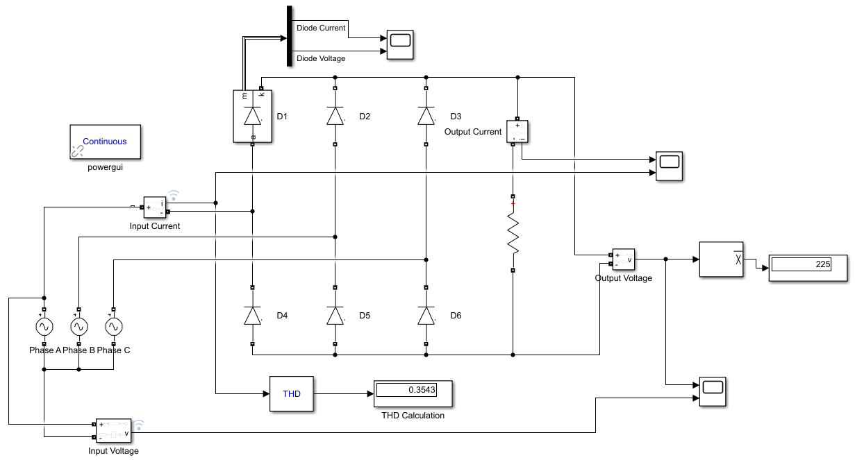

*Figure x. Circuit schematic for simulation of three phase diode rectifier.*

Simulation results of input and output voltage waveform are included in figure x.

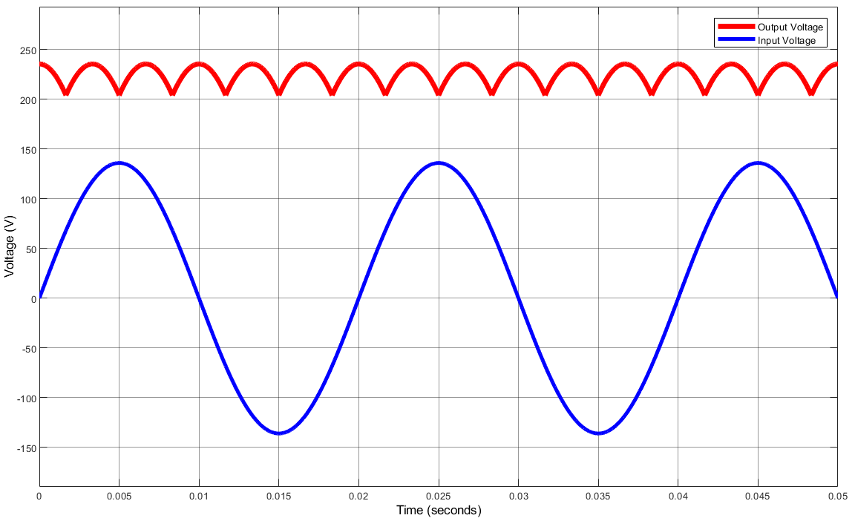

*Figure x. Input and output voltage waveforms of three phase diode rectifier.*

The simulation results of the input and output current waveform are given in figure x.

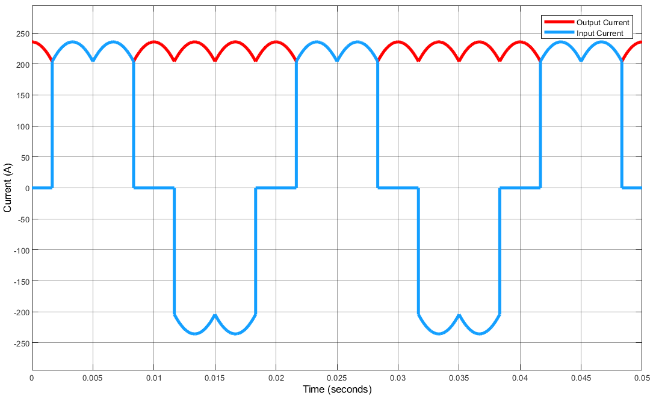

*Figure x. Input and output current waveforms of three phase diode rectifier.*

The waveform showing the voltage and current flowing through one of the diodes used in the rectifier is as in figure x*.*

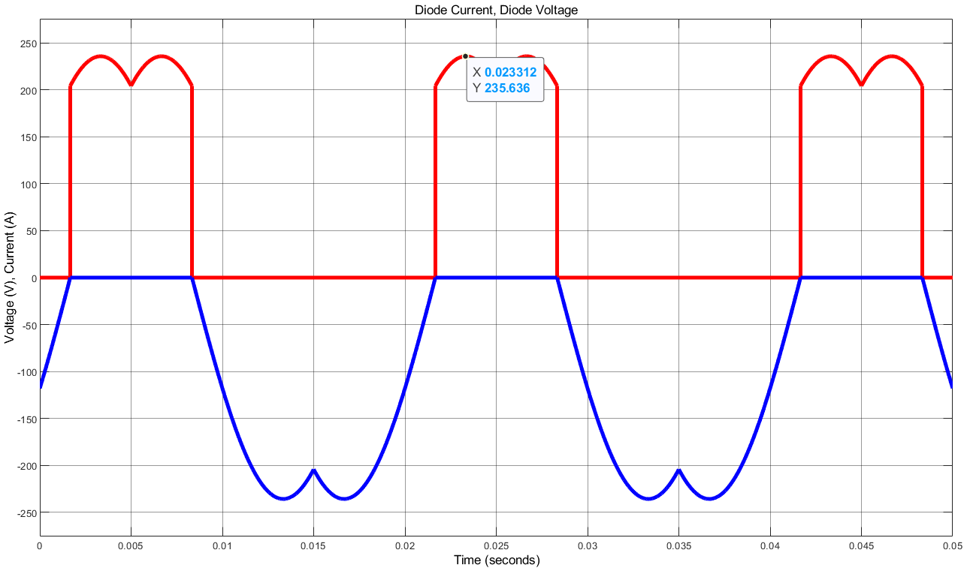

*Figure x. Diode current and voltage waveforms for three phase diode rectifier.*

Only 1ohm resistor was used as load in the simulation model. Since no capacitor is used as a load, the observed ripple voltage is higher than a capacitor rectifier. When we examined the simulation plots obtained, it was observed that the waveforms were according to the ideal case without line inductance and resistances as expected*.*

Since the resistance value used in the load is 1ohm and our diode is considered ideal, the maximum voltage value on the resistor and the maximum current that will pass through it are equal and 235.6V and 235.6A. The maximum current rating varies according to the resistance at the load.

## **Buck Converter Simulation**

Figure 2 shows the Simulink simulation schematic for the Buck Converter design. To view the output voltage and current, diode voltage and current and MOSFET voltage and current waveforms, the circuit is simulated on Simulink with duty cycle 10%.

The gate signal of a MOSFET or IGBT is selected using the controller, which is discussed later. The duty cycle is set at 0.1 at startup and subsequently climbs to 0.8. At first, the motor had no back emf because we applied 0.05 V to the load side, which is series to RL load. The DC motor itself is a RL load and an additional LC filter isn’t needed for the Buck Converter.

The motor parameters used to calculate R and L of the load. Resistance of the load is defined as 1.065 ohm and inductance of the load is 24 mH. MOSFET or IGBT has a switching frequency of 1 kHz.

To have a 180 V DC, 80% duty cycle is used for the gate signal of MOSFET. Output voltage formula for the basic buck converter can be seen from the equation above.

(2)

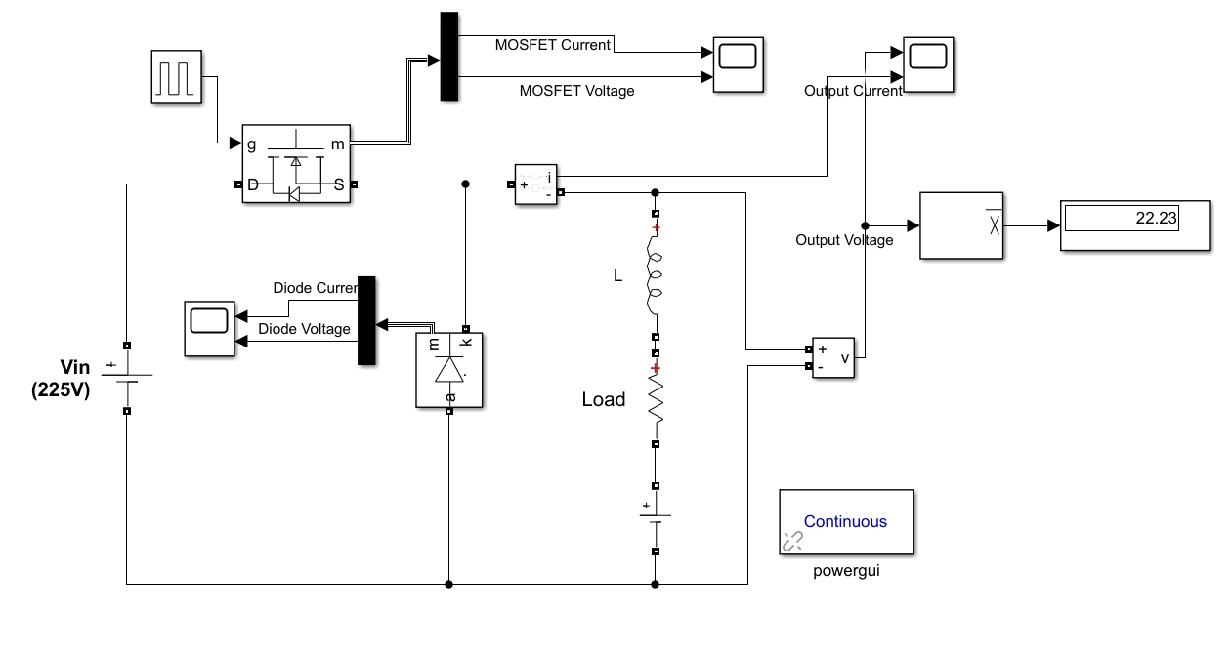

*Figure 2. Schematic of Buck Converter*

Figure 3 displays the output voltage and output current waveforms at duty cycle 10%. The ripple in the output voltage is measured to be close to 225 V.

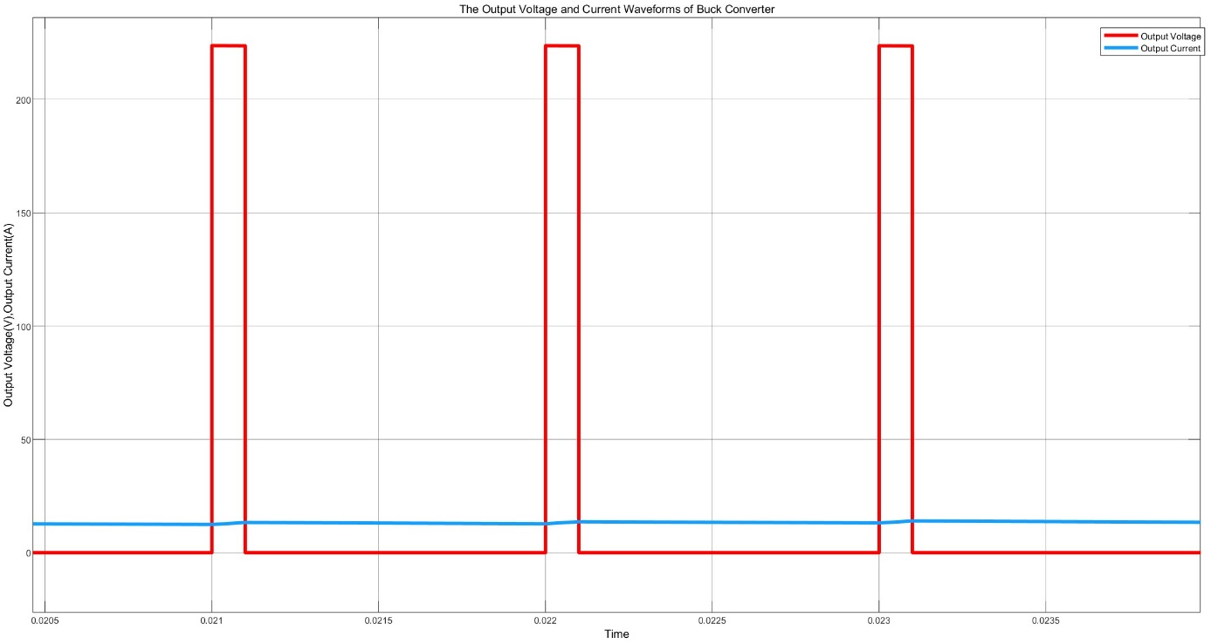

*Figure 3. Buck Converter Output Voltage and Output Current Waveforms*

MOSFET voltage and current waveforms are seen in Figure 4. Approximately 225 Volts is the MOSFET's maximum limiting voltage, and its maximum current is 15 Amps.

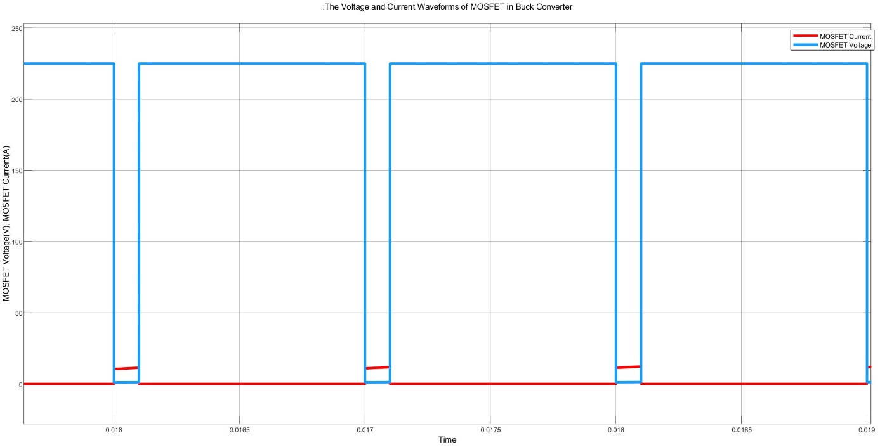

*Figure 4. The Voltage and Current Waveforms of MOSFET of Buck Converter*

The Figure 5 shows the voltage and current waveforms across the diode of the Buck Converter. The limiting voltage at the free-wheeling diode is about 224 V and the maximum forward current value is roughly 13 A.

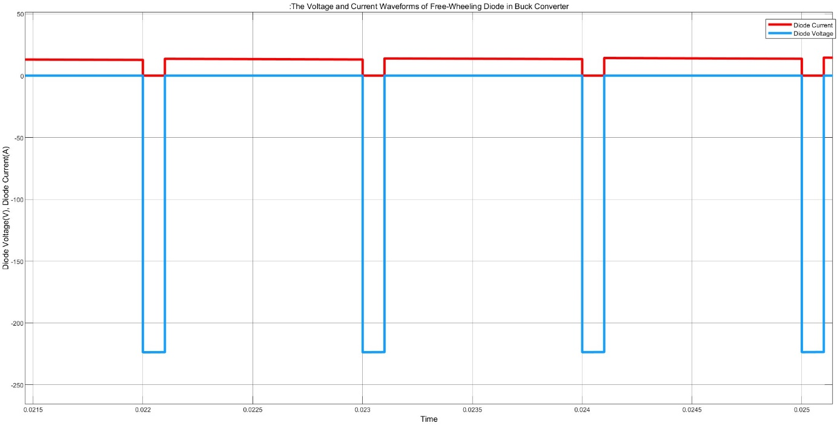

*Figure 5. The Voltage and Current Waveforms of the Diode of Buck Converter*

## **Three Phase Diode Rectifier and Buck Converter Simulation**

# **Simulation of Controller**

# **Component Selection**

**IXGH24N60C4D1 N IGBT**

We made the decision to use a MOSFET that can handle up to 15-20 A average current. According to the findings of the simulation, the MOSFET's voltage rating must be more than 225V. IXGH24N60C4D1 N Channel IGBT is available and a good choice for the design.

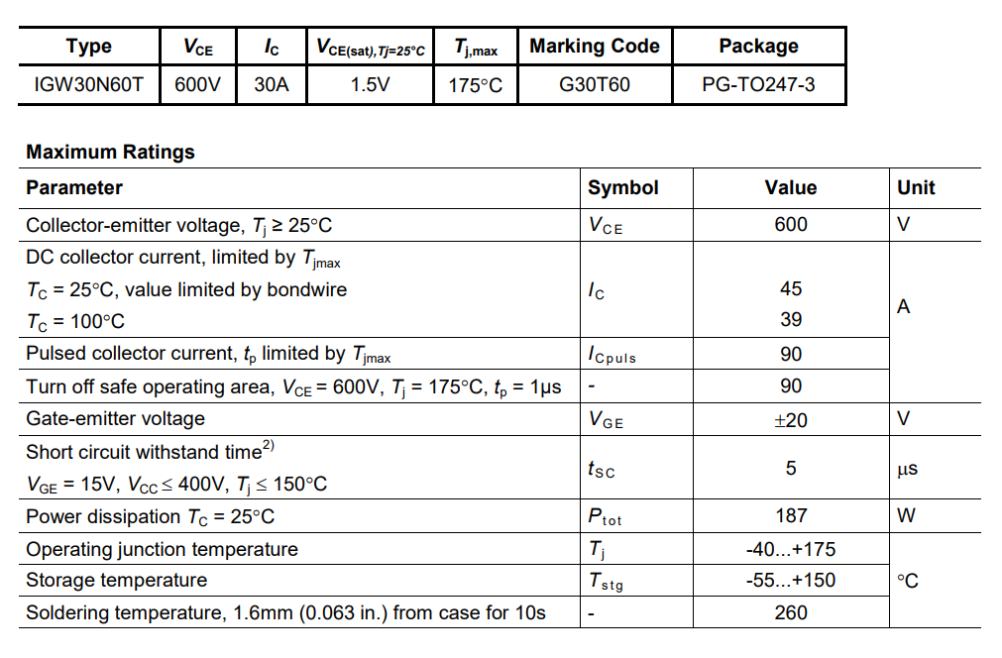

**GUO40-12NO1 Bridge Diode**

To maximize compactness and provide simplicity, we have decided to utilize one bridge diode as rectifying diodes on the input side rather than six individual diodes. Rectifier diodes shoul have a minimum operating voltage of 220 V and a minimum forward current of 23.4 A. 40 A and 1200 V are the limiting voltage and current values of this diode.

**DSEI30-06A**

For the rectifier’s diode we decided to use 6 DSEI30-06A. The reverse limiting voltage of this diode reaches up to 200 V average and 250 V peak.

**DSEP30-06B**

Reverse blocking voltage of free-wheeling diode is observed as 224 V and forward current observed as 13 A. DSEP30-06B has chosen as it carries the current until 30 A and has a reverse voltage limit of 600 V.

**100 µF 400 V Capacitor**

To reduce the voltage ripple, we decided to place a capacitor after the rectifier component. After factoring in a safety margin, we came to the decision to utilize a 100F 400V capacitor to work properly close to 250V.

# **Thermal Analysis**

# **Conclusion**

Our objective in this project is to design an AC/DC converter. We defined the case and investigated several topologies. By analyzing advantages and disadvantages of the circuit topologies we decided to construct Three Phase Diode Rectifier with Buck Converter.

Detailed simulations of the three-phase diode rectifier, buck converter and the three-phase diode rectifier with buck converter were made with addition of control input to MOSFET. Controller simulation was also made, and 555 Timer PWM Generator was used.

According to the voltage and current simulation results, the components to work with were decided. Thermal analysis of the components was made.

In conclusion, the study confirms the effectiveness of the decided technique at the theoretical and simulation levels.

# **References**